Extranet Android App
Generating Signed APK

Objective:
We need to release new versions of Extranet Android App, without uninstalling existing App and securing data in existing SQLite Database on user's phone device.
Using signed APK we can install new App versions without need to uninstall existing App and without overwriting SQLite Database on the user's phone device.

Steps for Generating Signed APK:

- Select “Build” from menu and navigate to select “Generate Signed Bundle/APK”.
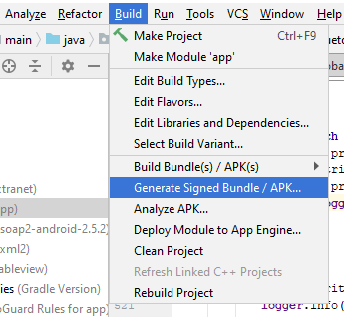

- Select APK option and Click Next button.
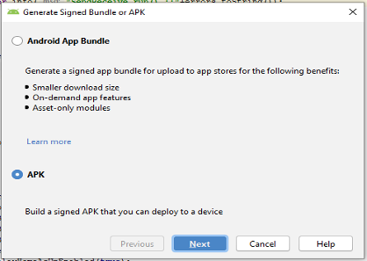

- On next screen click on “Choose existing...” button to choose “Key store path”

Search and Download the Extranet.jks from - http://workflow.envigil.net/PSWorkFlow.aspx?wid=111

- Enter the “Key store password” as: ExtranetDAEP
- Enter the “Key alias” as: key0
- Enter the “Key password” as: ExtranetDAEP
- Click on Next button
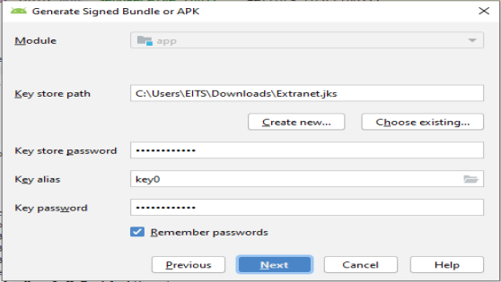
- Enter Destination Folder
- Select “release” in Build Variants.
- Check V2 (Full APK Signature)
- Click Finish button.
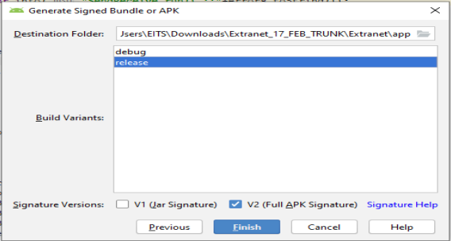
- The signed APK process starts.
- Locate the .apk file in below directory of project location on the computer.
Error:

- If android studio throws the following error for generating an APK, copy the highlighted part as in the screen print and paste it in the app level gradle file of the project. Else skip to step 8 after generation of the .apk file.

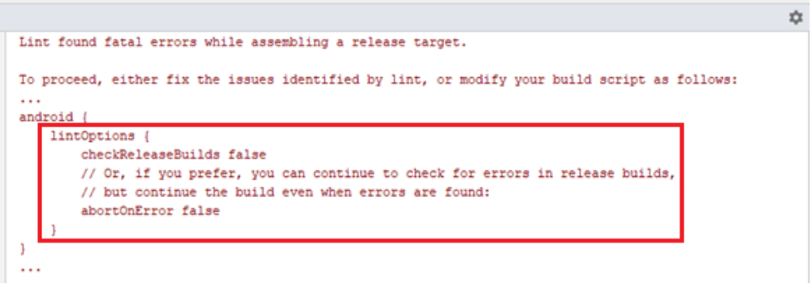

- Copy the above code in the gradle file and sync the project by clicking ‘Sync Now’ in the top right corner of the project window.
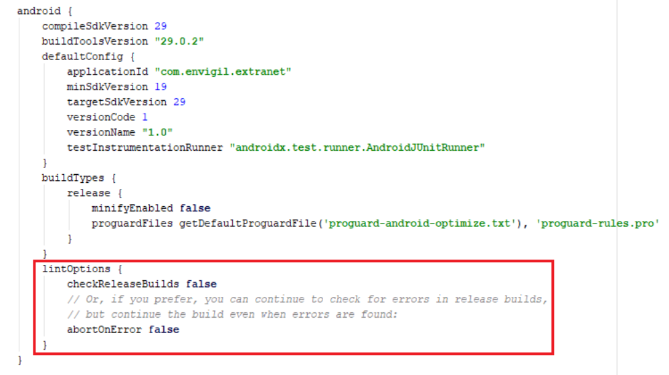
- After completing the gradle sync, repeat the Steps for Generating Signed APK.

